**INTRODUCTION**

The Sustainable Forestry Initiative® (SFI) [2022 Standards](https://forests.org/sfi-2022-standards/) include requirements that promote and conserve Forests with Exceptional Conservation Value (FECV), which includes critically imperiled (G1) and imperiled (G2) species. This fact sheet summarizes the analysis of FECV habitat within this ecoregion and provides habitat management recommendations that would benefit species potentially found here.

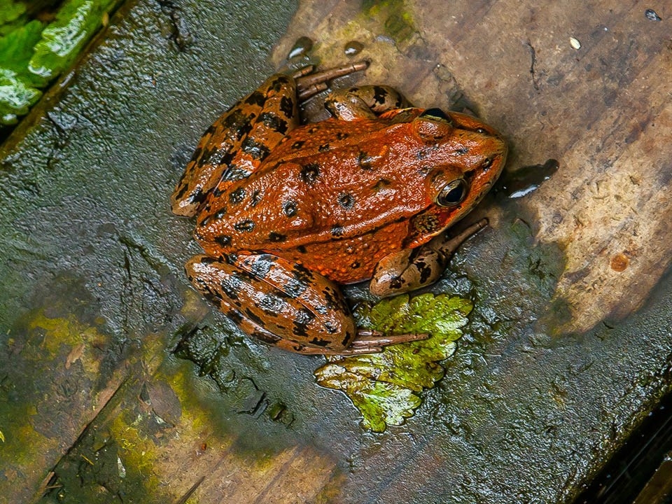

**California Reg-legged Frog**

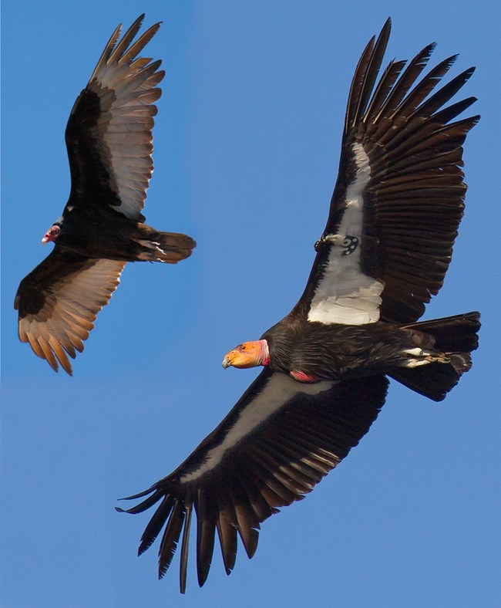

**California Condor**

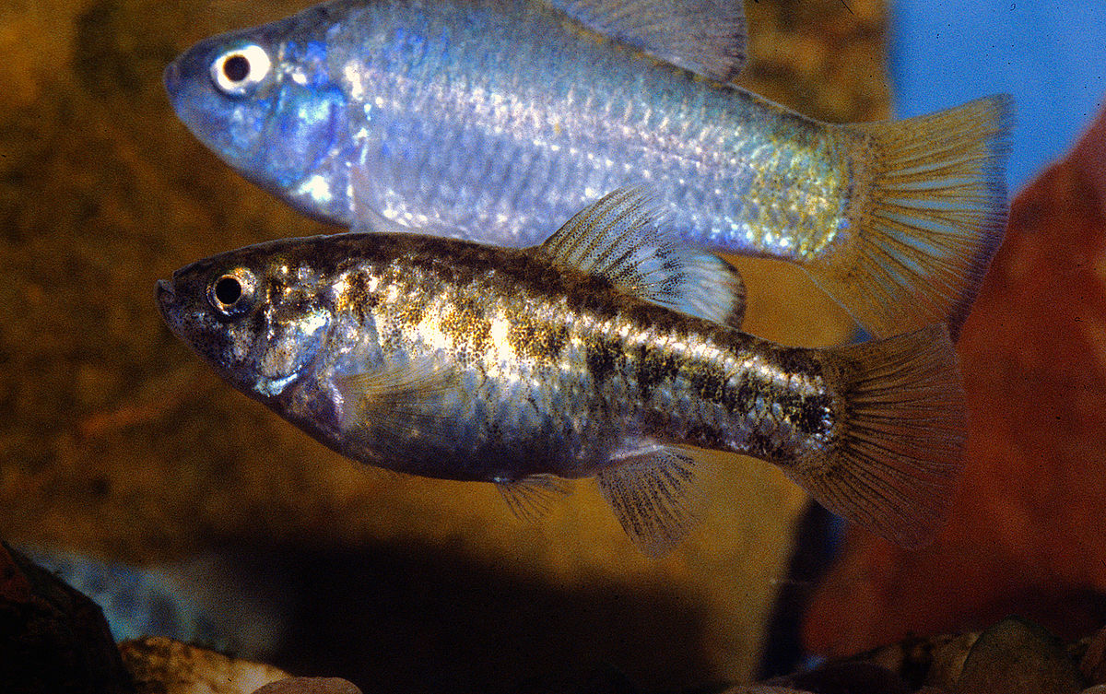**Desert Pupfish**

**HABITAT TYPES**

* Grassland
* Mixed Conifer Forest
* Riparian/Streams/Wetlands
* Shrubland/Chaparral
* Special Sites (Bare Rock/Talus, Desert, Dunes)

**GRASSLAND MANAGEMENT**

* Protect known locations
* Buffer grassland areas

**MIXED CONIFER FOREST MANAGEMENT**

* Protect known locations
* Retain legacy trees, stumps, and logs
* Retain large diameter trees with cavities or broken tops
* Leave skips and gaps with dense shrub component
* Retain large slash into piles

**RIPARIAN/STREAMS/WETLANDS MANAGEMENT**

* Protect known locations
* Maintain well vegetated riparian buffers
* Plant a diversity of both hardwood and conifer trees
* Retain large diameter trees near streams, rivers and wetlands
* Buffer wetlands, springs, and headwater areas

**SHRUBLAND/CHAPARRAL MANAGEMENT**

* Protect known locations
* Buffer shrubland and chaparral areas

**SPECIAL SITES MANAGEMENT**

* Protect known locations
* Maintain and buffer special sites

|  |  |  |  |
| --- | --- | --- | --- |
| **SCIENTIFIC NAME** | **COMMON NAME** | **HABITAT** | **STATUS** |
| [*Spermolepis infernensis*](https://explorer.natureserve.org/Taxon/ELEMENT_GLOBAL.2.960584) |  | Bare Rock/Talus | G1 |
| *Berberis harrisoniana* | [Kofa Barberry](https://explorer.natureserve.org/Taxon/ELEMENT_GLOBAL.2.134050) | Desert | G2 |
| *Euparagia unidentata* | [a wasp](https://explorer.natureserve.org/Taxon/ELEMENT_GLOBAL.2.159305) | Dunes | G1 |
| *Bombus crotchii* | [Crotch's Bumble Bee](https://explorer.natureserve.org/Taxon/ELEMENT_GLOBAL.2.159305) | Grassland | G2 |
| *Symphyotrichum defoliatum* | San Bernardino Aster | Grassland | G2 |
| *Gymnogyps californianus* | California Condor | Mixed Conifer Forest | G1 |
| *Astragalus oocarpus* | San Diego Milkvetch | Mixed Conifer Forest | G2 |
| *Marina orcuttii* | [Sonoran Desert Marina](https://explorer.natureserve.org/Taxon/ELEMENT_GLOBAL.2.100216) | Mixed Conifer Forest | G2 |
| *Draba corrugata* | [Southern California Whitlow-grass](https://explorer.natureserve.org/Taxon/ELEMENT_GLOBAL.2.100216) | Mixed Conifer Forest | G2 |
| *Gila elegans* | [Bonytail](https://explorer.natureserve.org/Taxon/ELEMENT_GLOBAL.2.105598) | Riparian/Streams | G1 |
| *Ptychocheilus lucius* | [Colorado Pikeminnow](https://explorer.natureserve.org/Taxon/ELEMENT_GLOBAL.2.104138) | Riparian/Streams | G1 |
| *Rorippa gambelii* | [Gambel's Watercress](https://explorer.natureserve.org/Taxon/ELEMENT_GLOBAL.2.146000) | Riparian/Streams | G1 |
| *Trichinorhipis knulli* | [Knull's Metallic Wood-boring Beetle](https://explorer.natureserve.org/Taxon/ELEMENT_GLOBAL.2.791807) | Riparian/Streams | G1 |
| *Xyrauchen texanus* | [Razorback Sucker](https://explorer.natureserve.org/Taxon/ELEMENT_GLOBAL.2.104297) | Riparian/Streams | G1 |
| *Rana muscosa* | Southern Mountain Yellow-legged Frog | Riparian/Streams | G1 |
| *Rana draytonii* | California Red-legged Frog | Riparian/Streams | G2 |
| *Hemizonia floribunda* | Tecate Tarweed | Riparian/Streams | G2 |
| *Spea hammondii* | Western Spadefoot | Riparian/Streams | G2 |
| *Tharsalea hermes* | Hermes Copper | Shrubland/Chaparral | G1 |
| *Atriplex parishii* | Parish's Saltbush | Shrubland/Chaparral | G1 |
| *Linanthus bellus* | Desert Beauty | Shrubland/Chaparral | G2 |
| *Cyprinodon macularius* | [Desert Pupfish](https://explorer.natureserve.org/Taxon/ELEMENT_GLOBAL.2.105718) | Wetland | G1 |

*\*Species links provided when available*